Assignment

Q1. In the band and block brake shown in Fig. 25.34, the band is lined with 12 blocks each of which subtends an angle of 15° at the centre of the rotating drum. The thickness of the blocks is 75 mm and the diameter of the drum is 850 mm. If, when the brake is inaction, the greatest and least tensions in the brake strap are T₁ and T₂, show that
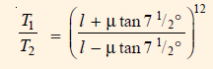
where is the coefficient of friction for the blocks. With the lever arrangement as shown in Fig. find the least force required at C for the blocks to absorb 225 kW at 240 r.p.m. The coefficient of friction between the band and blocks is 0.4.
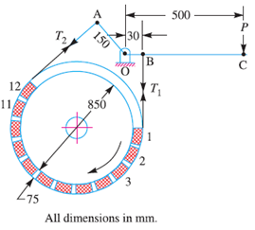
Q2. A differential band brake, as shown in Fig. has a drum diameter of 600 mm and the angle of contact is 240°. The brake band is 5 mm thick and 100 mm wide. The coefficient of friction between the band and the drum is 0.3. If theband is subjected to a stress of 50 MPa, find :
1. The least force required at the end of a 600 mm lever, and
2. The torque applied to the brake drum shaft.
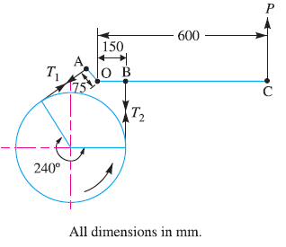
Q3. A differential band brake, as shown in Fig. has an angle of contact of 225°.The band has a compressed woven lining and bears against a cast iron drum of 350 mm diameter. The brake is to sustain a torque of 350 N-m and the coefficient of friction between the band and the drum is 0.3.
Find :
1. the necessary force (P) for the clockwise and anticlockwise rotation ofthe drum; and
2. The value of ‘OA’ for the brake to be self locking, when the drum rotates clockwise.
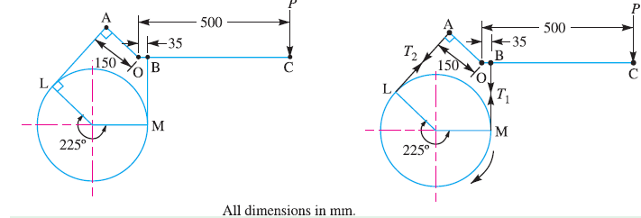

Q4. A band brake acts on the 3/4 th of circumference of a drum of 450 mm diameter which is keyed to the shaft. The band brake provides a braking torque of 225 N-m. One end of the band is attached to a fulcrum pin of the lever and the other end to a pin 100 mm from the fulcrum. If the operating force applied at 500 mm from the fulcrum and the coefficient of friction is 0.25, find the operating force when the drum rotates in the anticlockwise direction.
If the brake lever and pins are to be made of mild steel having permissible stresses for tension
and crushing as 70 MPa and for shear 56 MPa, design the shaft, key, lever and pins. The bearing
pressure between the pin and the lever may be taken as 8 N/mm².
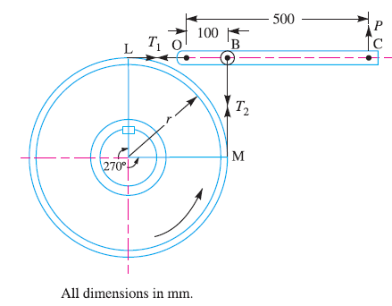
Q5. A simple band brake operates on a drum of 600 mm in diameter that is running at 200 r.p.m. The coefficient of friction is 0.25. The brake band has a contact of 270°, one end is fastened to a fixed pin and the other end to the brake arm 125 mm from the fixed pin. The straight brake arm is 750 mm long and placed perpendicular to the diameter that bisects the angle of contact.
(a) What is the pull necessary on the end of the brake arm to stop the wheel if 35 kW is being
absorbed ? What is the direction for this minimum pull ?
(b) What width of steel band of 2.5 mm thick is required for this brake if the maximum tensile
stress is not to exceed 50 MPa ?
